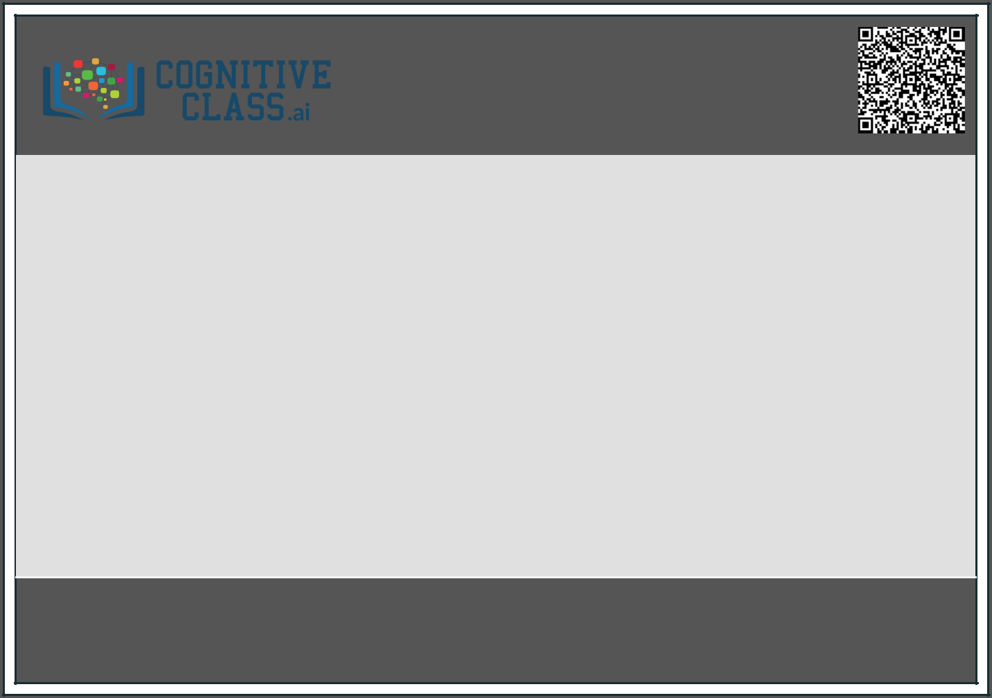

This is to certify that

**Nisha**

successfully completed and received a passing grade in

**Machine Learning with Python**

[(ML0101EN,](https://cognitiveclass.ai/) provided by **IBM**)

[A course](https://cognitiveclass.ai/) on **cognitiveclass.ai**

[Powered by **IBM**](https://cognitiveclass.ai/) Developer **Skills Network.**

Issued by

**Cognitive Class**

September 19, 2023

A uthenticity of this certifcate can be validated by going to:

https ://cours es .cognitiveclas s .ai/certifcates /d3da6cf 74f 9b49409a30ddb146572508